Lake Boon Improvement Association, Inc. 174 Barton Road
NONPROFIT ORG.
U.S. POSTAGE PAID
STOW, MA 01775
PERMIT #7
Stow, Massachusetts 01775
www.lakeboon.org

A smiley face on your address sticker means your LBA dues are paid up for 2021. Otherwise, please renew!

Since 1921

The Lake Boon Gazette
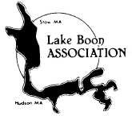published by the Lake Boon Association www.lakeboon.org
Volume 60, No.1 May 2021

Inside this issue:
Calendar of Events 2
Lake Boon Food Project 2
Shallow Well Data Needed 2
Healthy Lake Boon Progress 3
Lake Boon Commission Update 6
Aquatic Weed Treatment 6
Lake Boon Association through the Years 7
Lake Boon History References 9
Swim Lesson Fee Reimbursements 9
Membership/Donation Form 10
Officers and Directors 10

Lake Boon Association - 2021 Calendar

Note: Events are subject to change or cancellation due to Coronavirus restrictions and weather conditions.

Sunday, June 6

Lake Boon Association Annual Meeting, 7 p.m.
We will meet online via Zoom. You can participate on video or dial in by telephone and participate audio-only. Details for the call will be announced on the Lake Boon email list, and at www.lakeboon.org. If you are not on the email list please contact Dave Gray at grayscale@earthlink.net to sign up.

Friday, September 3 – Sunday, September 5, Labor Day weekend Lake Boon Water Carnival
Lighting of the Lake and Music Boat on Friday evening, Water Carnival at the Stow Town Beach on Saturday, Sunday afternoon’s boat parade, Sailboat regatta on Monday. All events—except for Saturday lunch—are free and open to all. Box lunches will be sold to benefit the Lake Boon Association and to support this annual event. Keep an eye on your email and local papers to see the final schedule for the weekend. And if you’ve enjoyed participating in past years, why not volunteer in 2021? For more information, contact Dave Siewierski at siewierski@darkhold.com. You can also make a donation to support the Water Carnival. Please see the membership form at the end of the newsletter, and thank you for your support!

Saturday, October 16, 11:30 a.m. Lake Boon History Walk
Enjoy the 5-mile stroll around Lake Boon back roads, viewing fall colors and signs highlighting sites of historic interest. The signs include maps and historic photos that show how life was back in the day at each location. Watch your email, www.lakeboon.org or the local papers for more info in the Fall.

Lake Boon Food Project Update
Despite COVID-19, the Lake Boon Food Project has been able to keep up our support of the Hudson and Stow food pantries. Though we cancelled our May 2020 pickup, we were able to resume in July with a collection for the Hudson Food Pantry, and then for both pantries on our regular every-other-month schedule starting in September 2020.
If you are interested in participating, please email Barbara Clancy at bclancy122@earthlink.net, or see the Food Project page on the LBA website. Donating is easy—pick up an extra item when you shop, add it to your donation bag, and then every other month, we pick up the bag with your donation and leave an empty bag to fill for the next pickup.
Many thanks to volunteer drivers/pickup crew Ellen Krag, Carolyn McDonald, Cindy Curley, and Dave Handrick, and to all the households who donated groceries or supported the pantries with online donations in this challenging year!

Shallow Well Data Needed !
Do you have a shallow drinking water well (less than 25 ft deep)? It could provide valuable information about ground water composition headed toward the lake in your area. If you have a recent analysis of your water before any treatment devices (softener, specialized filter, etc.), the Healthy Lake Boon project would appreciate receiving a copy.
If not, we would like to take a sample of your well water before treatment and have it analyzed for nutrients at no cost to you. This would give you the benefit of analysis results and give the project the benefit of more groundwater data. Results would be used only for the project and shared with you.
Please contact David Gray at grayscale@earthlink or 781-856-5158 if your well qualifies and you would like to participate.

Healthy Lake Boon Progress
The Healthy Lake Boon Initiative was conceived during the winter of 2019-20 from concern about the closing of the lake due to cyanobacteria blooms as well as general poor water quality. The Initiative envisioned a comprehensive lake management approach to maintaining and improving the health of the Lake for the environment and for recreation.
Key steps toward a Healthy Lake Boon:
- Past lake studies were reviewed and posted on the LBA website www.lakeboon.org under the Water Quality menu. They provide good historical data and show the need for a very thorough update.
- The LBA purchased a YSI portable meter, cable and sensor to measure depth profiles of dissolved oxygen, temperature and conductivity (dissolved minerals) which has been used monthly over the past year, even through the ice! A Secchi disk has been used to monitor water clarity.
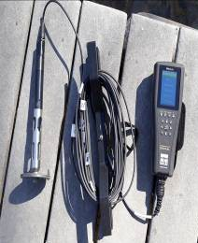
- The level and corresponding flowrate at the dam, rainfall and evaporation rates have been regularly monitored to develop an accurate hydrological lake model.
- 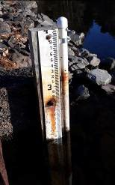Together with the Lake Boon Commission and
Conservation Commissions of Hudson and Stow we obtained a Massachusetts MVP (Municipal Vulnerability Preparedness) grant to thoroughly study the lake to understand its dynamics and identify factors to mitigate detrimental climate change effects.
- The Healthy Lake Boon MVP Project was structured with:
  - Dan Barstow - project manager and representing the LBC
  - David Gray - citizen science manager and representing the LBA
  - Kathy Sferra - Stow Conservation Commission
  - Pam Helinek - Hudson Conservation Commission
  - Additional Steering Committee members:
⋅ David Siewierski–LBA president
⋅ Sandra Grund—environmental consultant, certified MVP provider
⋅ Ingeborg Hegemann—naturalist, OARS board, Stow Conservation Commission
⋅ Julia Khorana—OARS director
⋅ Lauren Bullard—biology & sustainability teacher, Nashoba High School Green Team advisor
⋅ Emilie Wilder—wildlife biologist, Hudson Conservation Commission
- Brown and Caldwell was selected through competitive bidding to provide the project consulting and coordination services, contracted through the Town of Stow. Alpha Analytical, Westborough was similarly selected to provide laboratory water sample analysis services. U Mass. Dartmouth, School of Marine Science & Technology was selected to obtain and analyze sediment core samples in May 2021.
- We are very fortunate in having Kirk Westphal, the technical lead with Brown and Caldwell living right here on Lake Boon. With personal as well as professional interest in success and with daily access, he has provided invaluable guidance in many areas. It should be noted that Kirk was scrupulously excluded from all phases of reviewing proposals and awarding the contract for consulting services, in full compliance with Town policies.
- We elicited much appreciated Boonie volunteers to perform the Citizen Science monitoring and sampling, fundraising and other tasks for the project.

- We hired Rebecca Longvall as our part- time Citizen Science Coordinator to work with volunteers. She is the Bolton Conservation Agent with experience in coordinating volunteers and another MVP program, and has degrees in environmental studies. Volunteers include students in Nashoba High School’s extracurricular “Green Team.” Participation of students in the Hudson High School’s “Earth Council” is pending.
- 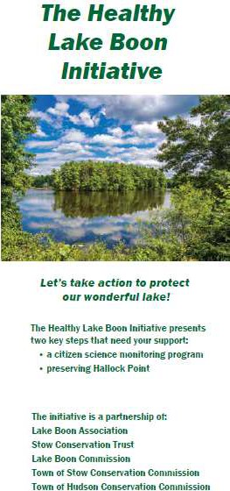We established a successful fundraising campaign to provide the required $18K in grant private matching funds.
- The opportunity to preserve Hallock Point in the 3rd and 4th basins as conservation land arose during the year. It was decided to bundle both the private funding match for the MVP grant and the $150K budgeted from private
funds for the Hallock Point acquisition effort into the same campaign. Both will benefit the health of the lake.
- We partnered with the Stow Conservation Trust to accomplish this and developed a brochure and GoFundMe site: https://tinyurl.com/HealthyLakeBoon.
> ADDITIONAL FUNDING IS STILL NEEDED!
- The Stow Community Preservation Committee, Conservation Commission, Finance Committee and Board of Selectmen have all enthusiastically recommended acquisition of Hallock Point for conservation.
- We held volunteer trainings on measurements and water sampling by Zoom and in person at Pine Bluffs beach to ensure quality Citizen Science work.
- The first monthly full-lake measurement and sampling run was accomplished on April 18th with the next (as of printing) scheduled for May 16th. Occasional special weather- related sampling runs will also be held.
- Sediment core samples were extracted by U Mass Dartmouth divers on May 1 for nutrient release analyses.

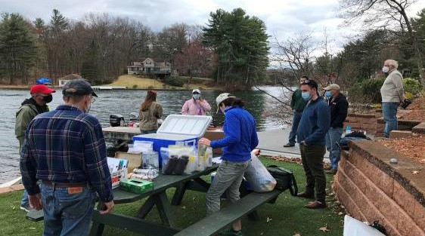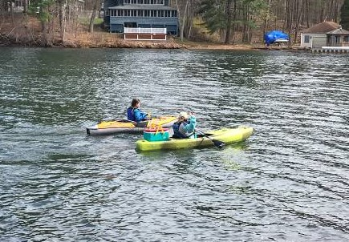

Citizen Scientists preparing to take water samples on April 18th

Next steps:
- Continue monthly monitoring and sampling.
- Work with our consultant to establish a project website with dashboard displaying measurement results, their significance and implications for lake management.

What will we learn?
As Boonies hear over and over, excessive aquatic plant growth and algae blooms are promoted by available nutrients. Phosphorus is the limiting nutrient to growth for most fresh water bodies but nitrogen can also contribute. Nutrients come into the lake by storm runoff which may include landscaping fertilizer, animal waste, street drainage, erosion, etc. Nutrients can also come into the lake from ground water that may include septic leaching and fertilizer that has percolated through.
The water flowing through the lake from various sources is important to quantify since it carries the nutrients in and out of the lake. Sediment at the bottom of the lake also contains nutrients, accumulated from decades of decaying leaves, wood, weeds, plus all the sources noted above.
Sediment phosphorus solubility and availability for biogrowth depends on the concentrations of dissolved oxygen at the bottom through the seasons. One goal is to understand the major sources of available nutrients to plan corrective actions. Another goal is to model the effects of climate change on the lake and identify what future mitigation may be needed.
These are key aspects of the study but additional characteristics and influencing factors are expected be revealed as monitoring and analysis progress.

What should we be doing now for a healthy lake?
- Limit surface runoff that carries nutrients
  - Don’t fertilize anywhere near the lake and obtain a soil analysis to see if it would be beneficial elsewhere
  - Plant vegetative buffer areas along the shore to absorb nutrients and discourage ducks and geese
  - Keep grass clippings and leaves out of the lake
  - Pick up after pets
  - Don’t feed ducks and geese
  - Wash cars away from the lake
- Maintain septic systems
  - Pump frequently, depending on occupancy and system size, usually every two years. A failed system is much more expensive!
  - Use no-phosphate dishwasher detergent
- Prevent additional invasive weed infestation
  - Learn to identify invasive weeds (especially water chestnut now in the Assabet River just below the dam) and inform the LBA if seen
  - Thoroughly clean boat hulls and bilges away from the lake after having been used in other water bodies and vice versa

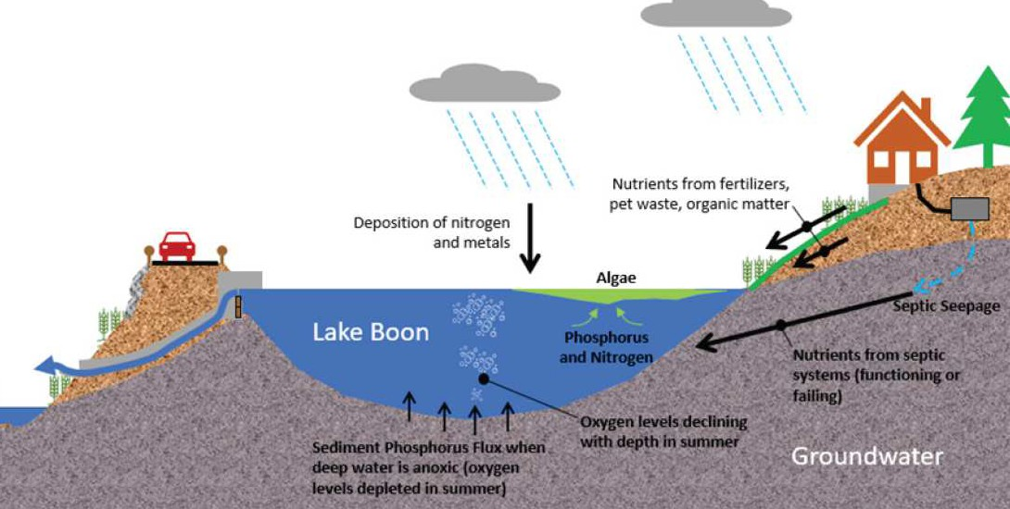
Paths that phosphorus and other nutrients take to enter Lake Boon courtesy Brown and Caldwell

Lake Boon Commission Update
As we head into the 2021 boating & swimming season here on Lake Boon, the Lake Boon Commission (LBC) is looking forward to the safe and responsible usage of this recreational treasure.
Whether you are new to the lake or have been here a lifetime, some things bear repeating.
This is a small body of water (a Great Pond of MA) and it is critical to the health of the lake and its shorelines, and the safety of its recreational users (for swimming, fishing & boating), that we all follow the MA State rules (Chapter 90B & 323 CMR) that govern boating, along with the Lake Boon Bylaws. You can find the Bylaws at https://www.stow- ma.gov/lake-boon-commission (along with other LBC resources), and information on Chapter 90B & 323 CMR on the MA.gov website. Links are also available at www.lakeboon.org.
As a reminder, the following are some key elements of applicable rules:
- No dumping of any refuse (including leaves & branches) into the lake
- Motorized boats must observe headway/no wake speed:
  - when operator’s vision is obscured
  - when within 150 ft of a swimmer, swimming area, raft or float
  - in the Narrows between each basin
  - from ½ hour after sunset until ½ hour before sunrise
  - from 2-6 pm every Sunday, and the MA State holidays of Memorial Day, Independence Day, Labor Day & Columbus Day
Additionally, jet ski speed is more restrictive and cannot be operated at more than headway speed within 150 ft of shore or a moored boat, and between sunset & sunrise
- A boat’s wake/wash is considered part of the boat, and operators are responsible for any damage or injury caused by their wake
- All motorized boats/vessels, including those with electric motors, must be registered
- As a public safety measure, all waterfront property owners must have their street address prominently marked in a manner that is visible from the lake
- Only 1 tow line from a boat, and not more than 2 persons on any towed device
- Buoys are put in place by LBC commissioners, who have Harbor Master authority for that. They are never to be used for mooring or moved by anyone other than the LBC.
- Enforcement: The Stow Police and MA Environmental Police patrol the lake from the water and shoreline

LBC Meetings: The LBC holds Public Meetings about 6-8 times throughout the year. These are posted at both the Stow & Hudson Town Halls, and on the town website calendars.

Enjoy the Lake!

LBC Commissioners: Kris Krablin (Stow) Dan Barstow (Stow)
Conray Wharff (Hudson)

Aquatic Weed Treatment
As of this writing, Solitude Lake Management, the LBC contractor for weed management, plans to survey the lake in late May and perform an herbicide treatment in mid- June. Watch your email or www.lakeboon.org for the specific treatment date and restrictions for use of the lake.

Lake Boon Association through the Years
In recognition of the 2021 LBA centennial the following was gleaned from newspaper clippings, meeting minutes, notices and Gazettes in the LBA archives stored at the Hudson Historical Society by Dave Gray plus additional research by Dick Gelpke.

Time Line
1903 - The first documented Labor Day Water Carnival celebration was held.
1921 - The LBA was incorporated as the Lake Boon Improvement Association, Inc. by seven Boston (and Lake Boon summer) residents for “…benevolent purposes including the promotion of temperance and morality in the Commonwealth, encouragement of athletic exercises or yachting, and the establishment and maintenance of places for reading rooms, libraries or social meetings, and in general to improve conditions of living and otherwise in the vicinity of Lake Boon.” The founding group first met in February 1921 at Hotel Bellevue in Boston.
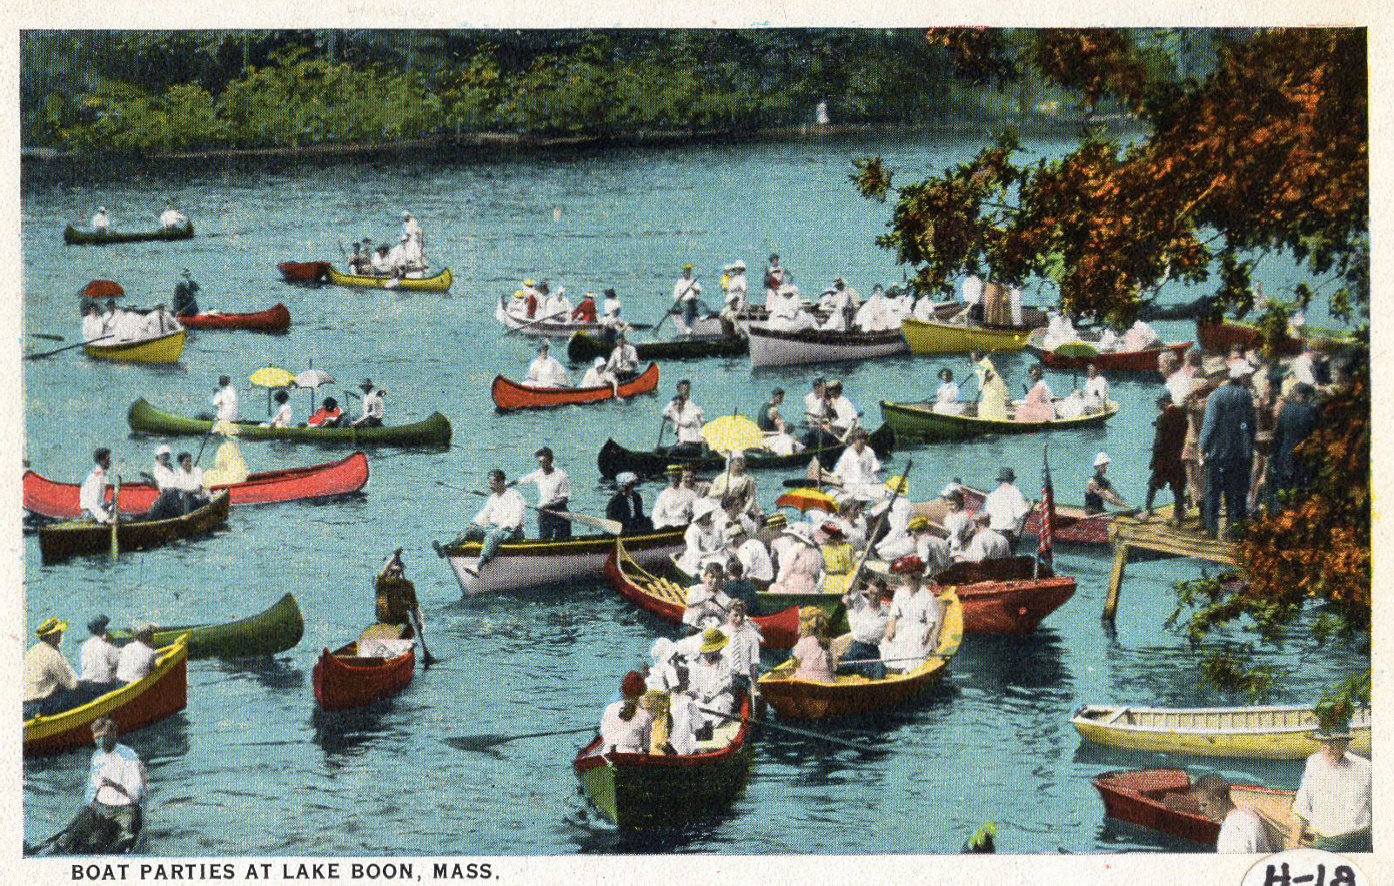
1941 - The Lake Boon Commission was chartered by the Massachusetts legislature, empowered to “…establish reasonable rules and regulations for the protection and policing of the waters of Lake Boone within the towns of Stow and Hudson.”
1949 - At the annual meeting, new bylaws were adopted and the name was changed from Lake Boon Improvement Association, Inc. to Lake Boon Association, Inc. Subsequently, the
organization became known as Lake Boon Associates, Inc.
1950s - Labor Day races were held at various locations. Early newspaper accounts announced Labor Day sports at the Twilight Club in the narrows. At least from the 1950s running races were held near Association Hall behind 201 Barton Rd and swimming races were primarily held at Hanson’s Beach at the very north end of the lake. By the late 1970s all races were held at Pine Bluffs Town Beach. Sept 1950 it was reported that “thousands participated in Labor Day activities…3 day events…races, boat parade, costume ball for roller skaters, water and fields events…”
1951 - Summer season plans: “The Lake Boone Associates will sponsor a public dance and auction on Saturday evening at the Association Hall at 8:00 PM under the direction of Mr. and Mrs. “Gene” Obey of Barton Rd. Paul Ambler and his orchestra will furnish the music and entertainment throughout the evening with “Gene” Obey, Roger Witherby and Herb Potter acting as auctioneers. These affairs sponsored by the Lake Boone Associates and have drawn a large attendance in the past, from Lake Boone and the surrounding communities...”
1960s - Attendance at Labor Day activities began to dwindle – down from thousands in earlier decades to “several hundred.”
1966 - LBA members “…purchased, at their own expense, an Aquatic Weed Cutter and Raking machine to control the weed Cabomba which has run rampant in Lake Boone. The machine, which cost $5000, was purchased with funds controlled by the residents there.” This was operated for four seasons in the shallower basins but ran into difficulties: the stumps damaged blades and it was very labor- intensive to remove the cut weeds from the water. Smaller cuttings were not captured and drifted to take root elsewhere.
1977 - Pine Bluffs Town Beach Recreation Area opened, providing an expanded venue for Water Carnival races and other events.

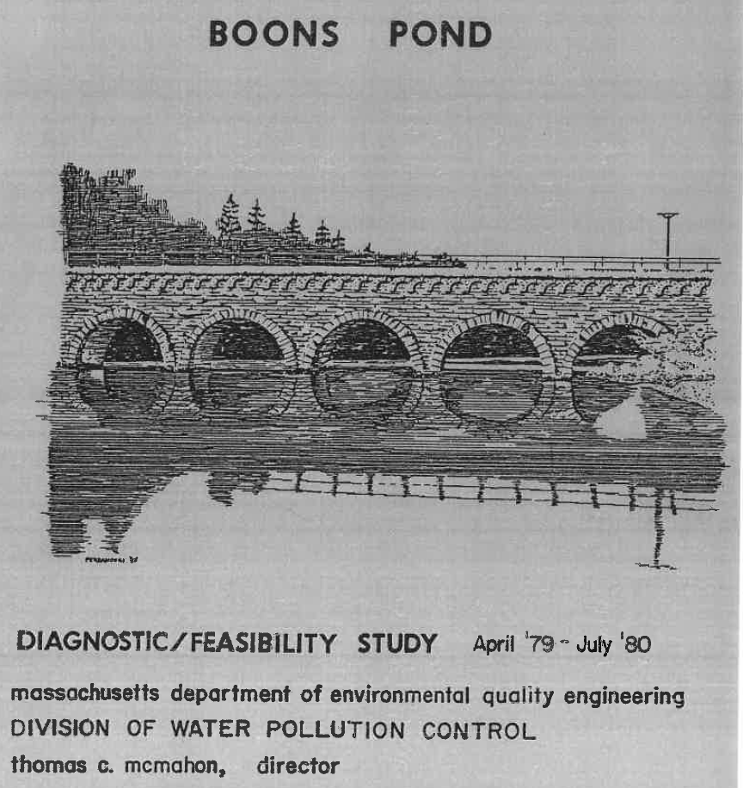
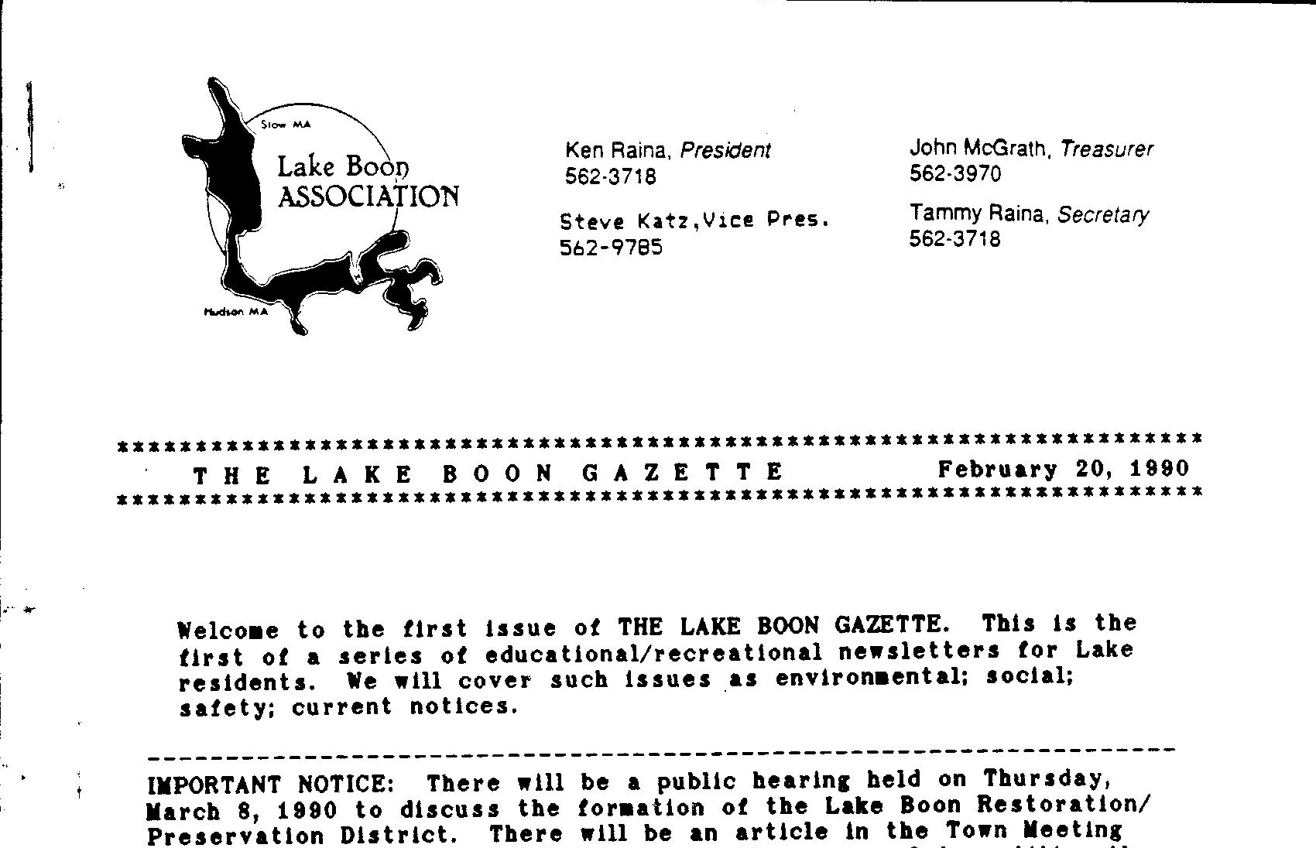1979 - The LBA sponsored the first major study of the lake, “Boons Pond Diagnostic/Feasibility Study,” conducted by the Massachusetts DEQ at no cost to the towns.

1979 - The LBA joined the newly formed Massachusetts Congress of Lakes & Ponds (MACOLAP) which convened meetings and published newsletters to discuss common problems and to raise awareness of new lake management techniques. It continued to bring leading consulting companies and lake people together.
1980s - The LBA’s focus further expanded to include environmental issues in addition to recreation, with more fundraising to support the 1987 Camp Dresser & McKee Diagnostic/Feasibility Study and to implement some of its recommendations.
1983 - The LBA negotiated donation of land by Robert Dawes to the Town of Stow for public lake access off Sudbury Road. Public access allowed Lake Boon to qualify for grants under the Massachusetts Clean Lakes program. That same year the LBA donated six “You are now entering the Lake Boon Watershed” signs posted on major roads to raise awareness of drainage into the lake.
1988 - The LBA attained 501c3 status and changed the name from Lake Boon Associates, Inc. back to the original incorporation name, Lake Boon Improvement Association, Inc.
1990 - The first issue of The Lake Boon Gazette with
current logo was published. Previous LBA communications were through informal newsletters and bulletins.
1990s - FOCUS (Families Organized to Clean Up Sites) was formed specifically to monitor the remediation of the Sudbury Annex (now Assabet River National Wildlife Refuge).
1994 - Notes by Alan Kattelle show the first documented boat history tour of the lake.
1995 - The Ronnie Fund was established to promote child safety around the lake, in memory of Ronnie Pastuck.
1997 - Friends of Lake Boon was formed to
investigate nutrients in the lake and was active in obtaining the ESS “Nutrient and Limnological Investigation of Lake Boon,” study completed in 1999 and the Mass DEP “Total Maximum Daily Loads of Phosphorus for Lake Boon,” completed in 2002.
2001 - LBA by-laws were changed to operate on a calendar year instead of the fiscal year August—July. Dues were raised from $5/$10 for single/family to $10/$20.
2005 - An s319 Non-Point Source Pollution Grant was obtained which funded installation of approximately 20 storm water catch basins in Hudson and one in Stow, a pilot project of aquatic plant replacement, and public education on lake-friendly landscaping.
2020 - LBA launched the Healthy Lake Boon Initiative and enlisted the LBC and Hudson and Stow Conservation Commissions to obtain a Massachusetts Municipal Vulnerability Preparedness grant. Brown and Caldwell was contracted for a comprehensive lake study including citizen scientists to understand current lake dynamics and anticipate climate change effects.

Lake Boon Association through the Years

Activities
Dances Beer blasts
Progressive suppers Raffles
Monte Carlo Nites Walkathons
Boat Parades Winterfests
Ice skating parties Membership drives Flea markets Auctions
Sailboat races Canoe races
Learn to ski program
Water Carnivals/swim races Historical Lake Tours Roadside cleanups
Meeting venues Poor Farm Lounge Monahans
Association Hall
Maynard Rod & Gun Club Stow Town Hall
Assabet River National Wildlife- Refuge Visitor Center
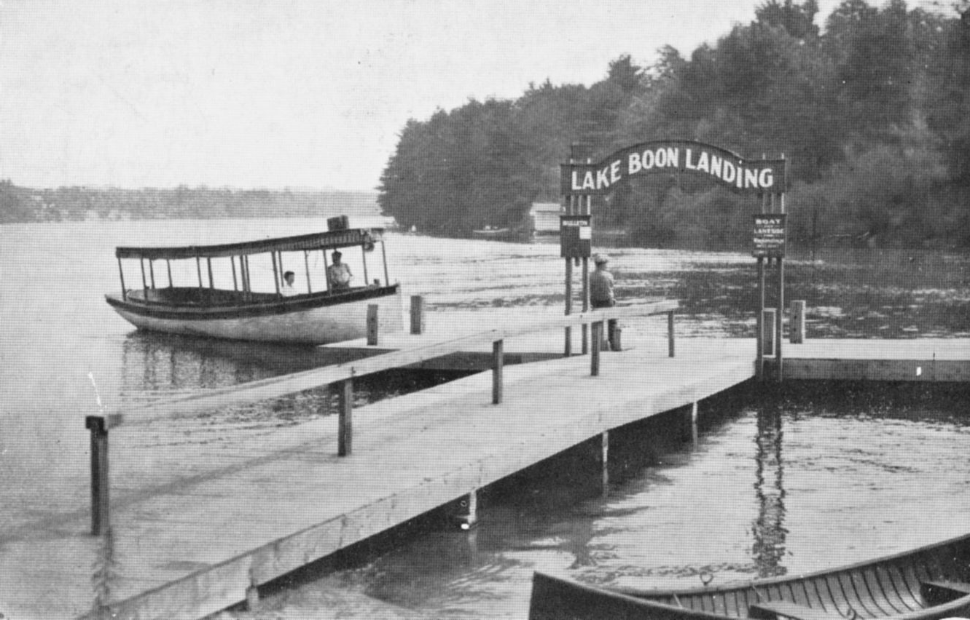Stow Pompositticut Community Center

Recent Presidents
Martin Higgins 1970
Bob Keene 1971
Eugene Curley 1972
Gary Twine 1973
David Wilbar 1975
Sidney Klein 1976
Pat Glover 1977
David Papuga 1982-3
Elizabeth Rose 1984
Todd Alving 1985-6
Ken Raina 1987-1999
Steve Katz (acting) 1999
Don Hawkes 2000-2
Lori Hawkes (acting) 2002 John JT Toole 2003
Barry Price 2004-7
Kent Seith 2008-13
David Siewierski 2016-

Lake Boon History References
- Images of America: Lake Boon, 1998, Arcadia Publishing Lew Halprin & Alan Katelle
- Postcard History Series: Lake Boon, 2005, Arcadia Publishing Lew Halprin & Alan Katelle
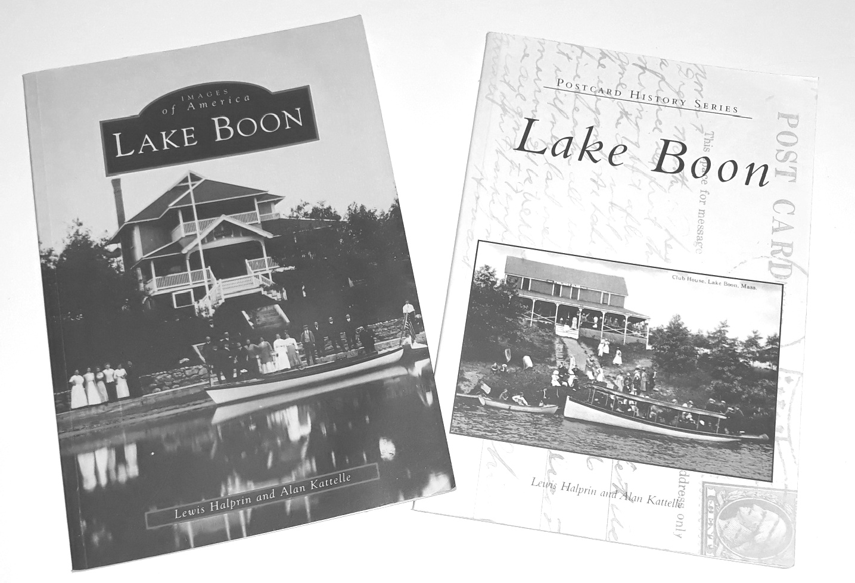
- Stories of Lake Boon, Soon to be published by Lew Halprin
- History of Lake Boon, an in-depth history, soon to be published by Richard Gelpke
- Presentations by Richard Gelpke available on Stow TV YouTube channel
- “Dams, Dams—Oh Where are the dams?” (Early Glaciers, Lakes and Dams) presented June 22, 2017 at the Assabet River NWR
- “Murder, Merriment & Monahan’s” (Life at Lake Boon, 1850-1950) presented July 27, 2017 at the Stow Community Center
- “Lake Boon, Then and Now”, presented Sept 23, 2015 at the Assabet River NWR
- “Evolution of the Lake Boon Community”, presented June 28, 2014 at the Stow West Schoolhouse

Swim Lesson Fee Reimbursement
Reimbursement for children’s swimming lesson fees is available through the LBA Ronnie Fund. The Ronnie Fund was established in memory of Ronald Pastuck to provide water safety and educational programs for children of residents 16 or under on the Lake Boon waterfront or with deeded lake access.
The Ronnie Fund will reimburse swimming lesson fees up to $70 per child per year if a copy of the receipt is provided to the LBA treasurer. Email Dave Gray at grayscale@earthlink.net for more information.
The Lake Boon Association is also looking for ideas for additional programs to promote child safety around the lake that could qualify for the Ronnie Fund. If you have an idea for such a program, please contact an LBA officer.

You have a stake in the lake — support the Lake Boon Association!
Join Now! All contributions are tax-deductible. Memberships run through the end of 2021 and you must be a member to vote at LBA meetings, hold office, or serve as volunteers in the name of the LBA.

Name:_

Address: _

Winter Address (if different):

Telephone: _ Email: _ □ Add me to the email list

Membership (circle one): Family: $20 Single: $10
Additional contribution(s): HEALTHY LAKE BOON INITIATIVE $ _ Ronnie Fund: $_

Herbicide Fund: $_
Water Carnival: $
Entertainment (Music at the Beach): $ _

TOTAL AMOUNT ENCLOSED (Membership plus contributions): $

Make checks payable to: Lake Boon Improvement Assoc. Inc., or LBA.
Mail to Dave Gray, Treasurer, 12 Pine Point Rd., Stow, MA 01775
(The Ronnie Fund was established in memory of Ronald Pastuck, age 3, to provide water safety and educational programs to residents of homes on the Lake Boon waterfront or with deeded lake access aged 16 and under.)

I’d like to volunteer for:
□ Water Carnival | □ Septic Pumping Program | □ Membership Committee
□ Lake Boon Walkathon | □ Street Cleanup | □ Healthy Lake Boon monitoring

Current LBA Officers and Directors:

President Dave Siewierski, 178 Barton Rd., Stow, 562-2203, siewierski@darkhold.com Vice President Dan Nicholson, 281 Sudbury Rd., Stow, 562-0237, dan_nick@hotmail.com Treasurer Dave Gray, 12 Pine Point Rd., Stow, 781-856-5158, grayscale@earthlink.net Secretary Kevin Hunt, 67 Hunter Ave., Hudson, 617-388-1344, kevinc.hunt@gmail.com Directors Kent Seith, 11 Hale Rd., Stow, 978-760-3483, kseith@gmail.com
Barbara Clancy, 201 Barton Rd., Stow, 793-4301, bclancy122@earthlink.net Lew Halprin, 82 Pine Point Rd., Stow, 562-9839, LHHalprin@gmail.com

Sign up for the Lake Boon email list! / Update us with your new email address!
The Lake Boon email list is the fastest way to stay informed about water quality, upcoming meetings, events, share wildlife sightings, post or receive lost and found notices, and find out about volunteer opportunities. Notify Dave Gray at grayscale@earthlink.net of your current email address.

Published by the Lake Boon Association, aka Lake Boon Improvement Association, Inc.

LBA website: www.lakeboon.org. LBA Facebook: https://www.facebook.com/lakeboonstow

